IP and Location Access Control
  - Implementation specification for FinProms Hub
Audience Product owners, backend developers, DevOps engineers and QA engineers
Status Proposed baseline for implementation and business approval

Purpose and recommended approach
Implement a server-side access policy that evaluates the trusted source IP and, where required, the country and city associated with that IP. Use the same decision service for protected web pages, APIs and live connections. An access-policy pass only permits the request to continue to the application’s normal identity and permission checks.
Recommended baseline: explicit denies take precedence; every applicable policy must pass; enabled allowlists deny unmatched requests; uncertain data must never silently satisfy an allow condition. Start country and IP controls in monitoring mode, then enforce after testing representative UK and Pakistan connections.

What this control can establish
IP geolocation describes the apparent network exit location. VPNs, corporate gateways, mobile networks and ISP routing can make this different from the person’s physical location. City accuracy is particularly variable [2]. Use city rules only after reviewing false-block risk. For sensitive administration, prefer an approved corporate VPN or static IP together with MFA.

Scope and assumptions
This design assumes a Laravel backend, React frontend, MySQL for configuration and audit records, and Redis for shared caches and invalidation. The exact Laravel configuration must follow the version deployed [3]. The design supports a platform, networks or tenants, and individual users without allowing a lower scope to weaken a higher scope.
Public marketing pages may remain outside the protected scope. Login, password reset, token refresh, downloads, uploads, exports and all protected API routes must have explicit coverage. Service integrations require a separately defined policy, described on page 7.

Document map
2 Policy configuration and rule model
3 Matching semantics and precedence
4 Request decision diagram
5 Trusted request data and geolocation
6 Backend implementation and decision algorithm
7 Sessions and integration traffic
8 Administration and operations
9 Audit records and performance
10 Acceptance tests and reference material

Policy configuration and rule model
Store policies as versioned snapshots. Global policies are mandatory for everyone. A tenant policy adds constraints for that tenant; a user policy adds constraints after verified identity is available. Policies combine using AND. Rules within a single enabled allow gate combine using OR.
Configuration | Required behaviour
Scope | GLOBAL, TENANT or USER; tenant and user identifiers are server controlled.
State | DRAFT, MONITOR or ENFORCE. DISABLED contributes no gate and is audited.
IP allow gate | Explicit enabled flag plus a list of IPv4 or IPv6 addresses and CIDRs.
Country allow gate | Explicit enabled flag plus ISO 3166-1 alpha-2 country codes, such as GB and PK.
City allow gate | Explicit enabled flag plus provider city ID, country code and subdivision where available.
Deny rules | Enabled IP, country, city or conjunctive conditions. All applicable deny rules are evaluated before final allow.
Validity | UTC valid_from inclusive; valid_until exclusive; omitted end means no expiry.
Lifecycle | Version, author, approver, reason, activation time and rollback reference.

Rule record
Each rule needs id, policy_id, action, predicate, enabled, valid_from, valid_until, description, created_by and change_reference. DENY is a rule action; ALLOW predicates belong to a named allow gate. Do not add a free-form numerical priority field in the first version; fixed precedence is easier to explain and test.

Composite conditions
Within one predicate, populated fields combine using AND. Example: country = GB AND city_id = Newcastle’s provider identifier. Values within one field combine using OR. Use separate predicates for alternatives such as an office IP OR a particular country; do not turn all allow settings into a single permissive OR expression.
An enabled allow gate with no active entries fails closed. This includes a gate whose last temporary entry has expired. A disabled gate imposes no restriction. The UI must make this distinction visible and prevent accidental empty-gate activation.

Matching semantics and precedence

Mandatory evaluation order
1. Validate request provenance, source IP and policy availability. Invalid or ambiguous source data cannot pass. Failure to load a usable policy snapshot blocks protected access.
2. Evaluate IP deny predicates. A match blocks immediately.
3. Resolve geography only if needed. Evaluate remaining deny predicates using three-valued logic. TRUE blocks; UNKNOWN also blocks because a configured denial cannot be excluded.
4. Evaluate every enabled allow gate. Each gate needs at least one TRUE predicate; FALSE or UNKNOWN alone cannot pass it.
5. Combine all applicable enforcing policies with AND. On network PASS, continue to authentication, MFA and resource authorisation.

Three possible predicate results
TRUE means all required fields are known and match. FALSE means at least one known condition fails. UNKNOWN means no known condition fails but a required field is missing, stale beyond its permitted age or unusable. Thus GB AND city X is FALSE for a known PK address even when its city is unknown. It is UNKNOWN for a known GB address with no usable city.
Situation | Decision
Allowed IP also matches denied country | BLOCK. An ordinary allowed IP does not override a geographic deny.
Allowed country but explicitly denied IP | BLOCK. Deny wins regardless of address specificity.
IP allow gate and country allow gate enabled | Both gates must pass; matching just one is insufficient.
Two countries in one country allow gate | Either country can satisfy that gate.
Global passes but tenant or user policy fails | BLOCK. Lower scopes can only add restrictions.
Required deny geography is unknown | BLOCK with GEO_REQUIRED_UNKNOWN; never assume no match.
No allow gates enabled and no deny matches | PASS at the network layer under the explicitly configured denylist-only mode.
No usable policy snapshot | BLOCK with POLICY_UNAVAILABLE; do not substitute an empty permissive policy.

There is no automatic “most specific rule wins” behaviour. An exact /32 or /128 allow entry cannot bypass a denied subnet. An exception requires a reviewed policy change; this version has no hidden override checkbox.

Request decision diagram
Evaluate this flow for the policies available before authentication, then repeat it with any newly applicable user or tenant policy before issuing a session or returning protected data. Every enforcing scope must pass.
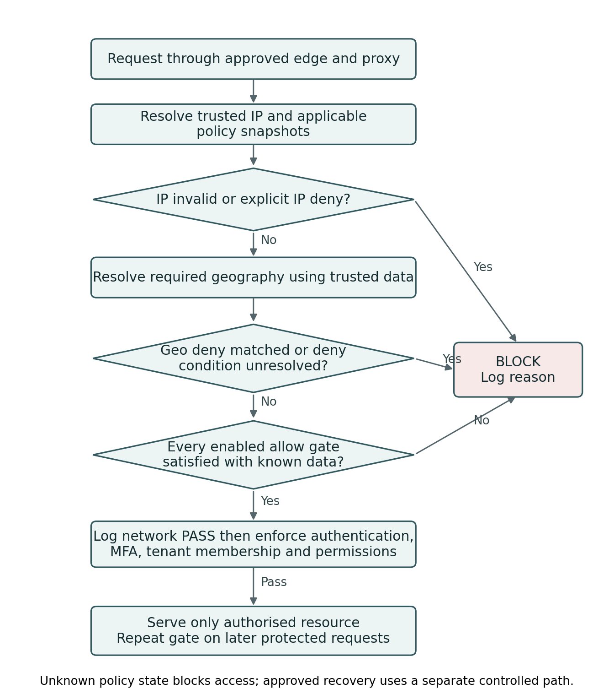
Figure 1 Network access decision flow. A block returns a generic response and records the internal reason. Identity and resource checks remain mandatory after a network pass.

Trusted request data and geolocation

Establish the real source IP
The edge must remove or replace client-supplied forwarding and geo headers. Restrict origin ingress to approved reverse proxies or load balancers; close alternative hostnames and exposed origin ports. Otherwise a caller can bypass edge rules or forge geography.
Configure Laravel trusted proxies and accepted forwarding headers for the actual deployment [3]. Use the framework’s trusted-proxy-aware request IP resolution after that configuration. Do not read the first X-Forwarded-For value or trust X-Real-IP, Forwarded or CDN country headers from arbitrary clients. Avoid a wildcard proxy trust setting unless infrastructure provably prevents direct origin access.

Canonical IP handling
Parse IPs with a maintained library. Match CIDRs using binary network operations rather than string prefixes. Support IPv4 and IPv6 equally; normalise IPv4-mapped IPv6 consistently to prevent duplicate or bypass behaviour. Reject malformed IPs, zone identifiers, hostnames and ambiguous textual forms. Store canonical binary addresses where practical and canonical CIDRs for rules.
Private, loopback, link-local and reserved addresses are not valid public geolocation inputs. If the derived public-client address is non-public, block protected internet traffic as IP_NOT_PUBLIC and alert on probable proxy misconfiguration. Internal service routes use an explicitly separate service policy.

Resolve and qualify geography
Use a maintained local IP database where practical, avoiding a third-party network call for every request. Alternatively use authenticated provider responses with strict timeouts and a circuit breaker. Accept edge-supplied geography only from the trusted, sanitising edge. Do not use browser GPS, submitted city names or profile addresses as proof of source location.
Store network country, provider city ID, subdivision, provider name, dataset version and lookup timestamp. Use the network country field consistently, rather than mixing it with registered-country or represented-country fields. Country code is GB for the United Kingdom. A city rule must bind to a provider ID and country; display names are labels only.
Missing country and missing city are separate states. Confidence and accuracy radius may be used only when the provider exposes them. Never invent confidence scores. A city value that fails the configured quality threshold becomes UNKNOWN; country checks may still work. Changing provider requires a reviewed city-ID migration.

Failure behaviour
If no enabled rule needs geography, a geo-provider outage must not block IP-only evaluation. If geography is required, use a still-valid local snapshot or cached result; otherwise apply UNKNOWN semantics. An allowed IP cannot silently bypass this failure. Database age and cache age limits must be configured and monitored.

Backend implementation and decision algorithm

Laravel components and request placement
Create a RequestContextResolver, PolicyRepository, GeoResolver and pure AccessDecisionService. Middleware orchestrates these services; controllers and React must not duplicate policy logic. The service returns PASS, BLOCK or WOULD_BLOCK, plus internal reasons and matched rules. OWASP recommends default denial and checks on every request [1].
Run global and trusted-host tenant checks before expensive login handling. After authentication, verify tenant membership and user scope, then run all remaining network gates before creating tokens or returning data. On authenticated API calls, resolve the verified identity before evaluating user-scoped gates. Never derive the policy scope from an unverified tenant_id in a request body.

Deterministic reference algorithm
context = resolveTrustedContext(request)
if not context.valid: return BLOCK(IP_CONTEXT_INVALID)
policies = loadApplicableVersionedSnapshots(context)
if not policies.usable: return BLOCK(POLICY_UNAVAILABLE)
results = []
for policy in policies:
if policy.disabled: continue
if anyTrue(policy.ipDenies, context):
result = BLOCK(IP_DENIED)
else:
geo = resolveIfRequired(policy, context.ip)
denies = evaluateThreeValued(policy.otherDenies, context, geo)
if TRUE in denies: result = BLOCK(GEO_DENIED)
elif UNKNOWN in denies: result = BLOCK(GEO_REQUIRED_UNKNOWN)
elif anyGateLacksTruePredicate(policy, context, geo):
result = BLOCK(ALLOW_GATE_UNSATISFIED)
else: result = PASS
results.append(policy.mode, result, policy.version)
recordDecision(context, results)
if anyEnforcingBlock(results): return BLOCK
return PASS # monitoring failures remain WOULD_BLOCK in logs

Response contract
Return HTTP 403 for a determinate policy refusal and HTTP 503 for unavailable policy or required geolocation infrastructure. Missing or unusable location with otherwise healthy infrastructure remains a 403. Return a neutral message such as “Access is unavailable from this connection. Contact support with reference ABC123.” Do not reveal blocked countries, policy rules or account existence. Mark denials and personalised responses Cache-Control: no-store.

Sessions and integration traffic

Protect the complete access path
Apply network policy to initial login, MFA completion, session creation, token refresh and every subsequent protected HTTP request. Session cookies and valid JWTs must not bypass the gate. Cover downloads, signed storage URLs, GraphQL, alternate API versions and internal Python services exposed through the gateway.
Keep object storage private. If direct signed downloads remain possible, document that a URL already issued may work until expiry without a new app policy check. For strict enforcement, proxy protected downloads through a gate or use equivalent edge enforcement; short URL expiry only limits this gap.

IP changes and existing sessions
Re-evaluate using the new trusted source IP on the next request. If policy fails, deny further protected access; apply the session security policy to revocation or step-up MFA. Do not revoke an entire account merely for one failed network attempt. Mobile IP changes are normal, so avoid rigid session-to-IP binding as the sole identity defence.
For WebSockets or server-sent events, check at connection and subscription time. Re-evaluate on protected messages and policy-version changes, and use periodic checks for idle connections. Recommended targets: policy revocations reach HTTP enforcement within 60 seconds and live connections within 60 seconds. Measure these targets; long-running exports must re-check before publishing output.

Human and service traffic need different policies
Traffic | Required handling
Human application and admin routes | Apply platform, tenant and verified user gates; MFA and role checks still apply.
Payment and other provider webhooks | Dedicated exact route and service policy; verify provider signature, timestamp and replay protection. IP ranges are supplementary.
Server to server APIs and workers | Scoped service identity with token or mTLS. Explicit network policy; no blanket exemption for API paths.
Health checks | Minimal non-sensitive health endpoint; restrict detailed readiness and diagnostics to infrastructure.
Emergency recovery | Separate audited management path through private infrastructure and strong identity. No public bypass query parameter.

Exemptions must identify an exact route, HTTP method, service principal and justification. A webhook exemption from human city rules must never exempt neighbouring application routes or remove signature verification.

Administration and operations

Settings workflow
Provide separate settings for platform security administrators, tenant security administrators and authorised user-policy managers. Enforce these capabilities on the backend. A tenant administrator may edit only their tenant’s additive controls and cannot disable platform restrictions. All policy editors must use MFA; high-impact changes require a second authorised approver.
The editor should provide typed IP/CIDR inputs, country selection and provider-backed city search showing country and subdivision. Show the effective scope, rule action, gate status, expiry in local time with UTC storage, and a readable explanation of AND/OR behaviour. Show the administrator’s derived IP and location for review without treating those values as ground truth.

Safe activation
Save draft → validate → simulate → monitor → approve → activate atomically. The simulator must use the production decision engine and show matched rules, unresolved fields and every failing scope. It must be an authenticated admin tool, not a publicly exposed arbitrary IP lookup endpoint.
Validate IP syntax and CIDR bounds; reject invalid country codes, duplicate city identities, inverted validity periods and empty enabled allow gates. Warn about broad /0 ranges, overlapping allow and deny rules, unreachable allows and future expiry that will empty a gate. Reject edits that the author is not authorised to make.
Simulate the current administrator connection, approved recovery network, known UK client connections and Pakistan support connections. A self-lockout warning is advisory only; a separate pre-established management recovery path is essential. Do not grant a secret bypass to the current editor.

Policy change and recovery
Publish one immutable policy version in a database transaction, increment its version and invalidate all related decision caches across instances. Retain prior versions for reviewed rollback. On storage failure, use the last verified local snapshot only while within the configured maximum age; otherwise fail closed with 503. Alert on fallback and stale versions.
A recovery operator uses a restricted management CLI or private console with a short-lived, audited action to restore the last known good snapshot. Record operator, reason, affected policy, old and new versions, timestamp and expiry. Test the recovery procedure before enforcement.

Suggested initial production settings
Use ENFORCE only after a monitored trial. For a UK-and-Pakistan operating model, GB and PK are candidate country allowances, subject to business approval and real connection testing. Keep city allowlisting disabled initially. Add tightly scoped admin IP controls where stable egress exists. Do not enable geo restrictions based solely on the target sales market.

Audit records and performance

Persist the configuration and decision evidence
Record | Suggested fields
access_policies | id, scope_type, scope_id, mode, gate flags, version, valid_from, valid_until, author and approver.
access_rules | id, policy_id, immutable version, action, gate, typed predicate JSON, enabled, validity and reason.
policy_changes | actor, approver, before and after versions, timestamp, change reason and rollback link.
access_decisions | UTC time, request ID, canonical IP, geo status and provenance, tenant/user if verified, route class, policy versions, result, matched rule IDs and reason codes.

Validate predicate JSON against a strict schema before publication. Treat every effective snapshot as immutable. Audit metadata must make it possible to explain a historic decision even after the configuration or geo database changes. Avoid storing passwords, tokens, request bodies or full query strings in decision records.

Reason codes and observability
Use stable internal codes: IP_CONTEXT_INVALID, IP_NOT_PUBLIC, IP_DENIED, COUNTRY_DENIED, CITY_DENIED, GEO_REQUIRED_UNKNOWN, ALLOW_GATE_UNSATISFIED, POLICY_UNAVAILABLE and NETWORK_PASS. Include the exact failed gate and scope internally. Multiple failures may be retained in simulation; production may stop at the first decisive failure.
Capture all denials, monitoring failures, privileged access and policy changes. Queue routine decision events to a durable sink and aggregate or sample ordinary passes under an approved logging policy. Alert on log-pipeline loss; do not silently drop required security events. Add metrics for deny rate by reason, UNKNOWN rate, dataset age, policy propagation lag and decision latency.

Caching and suggested operational defaults
Cache geo results by canonical IP, provider and dataset version. Suggested initial geo TTL: 24 hours, capped by dataset expiry; negative lookups: 60 seconds. Attempt daily database updates and flag datasets older than 7 days as unusable for required geo rules. These are proposed operating values, not guarantees of location accuracy.
Prefer caching compiled policy snapshots over final access decisions. If decisions are cached, the key must include canonical IP, trusted tenant, verified user where applicable, route class, all policy versions and geo dataset version. TTL must not cross rule start/end times and should be at most 60 seconds. Policy change must invalidate entries immediately.
Benchmark an initial target of under 10 ms p95 added latency for local cached evaluation at the expected load. Use bounded timeouts for remote lookups and avoid synchronous geolocation dependencies where possible.

Data handling
Treat IP and identity-linked location records as sensitive operational data. Restrict access, encrypt storage and transport, and define deletion schedules for audit logs and caches. A provisional 90-day decision-log retention may be a starting point for review, not a default compliance claim. Record the chosen purpose and provider data-sharing arrangement; do not request precise GPS for this control.

Acceptance tests and reference material
QA must verify identical decisions through browser, direct API and alternate ingress attempts. Use synthetic geo fixtures and documentation IP ranges; never depend on a real city lookup for deterministic tests. GB and PK here illustrate configuration, not production approval.
Case | Expected result
GB and PK allowed; known GB request | PASS if all other applicable gates pass.
Allowed IP but explicit country deny | BLOCK; ordinary allow cannot override deny.
Country allowed but IP allow gate fails | BLOCK; enabled allow gates combine with AND.
Country allowed and city explicitly denied | BLOCK, even with a matching IP allow entry.
City required but unavailable | BLOCK; never satisfy a city allow with unknown data.
Denied city predicate GB AND city X; known PK, no city | Predicate is FALSE; other policies decide the request.
Geo outage with IP-only policy | Evaluate IP rules normally; no unnecessary geo failure.
Enabled allow gate empty or all entries expired | BLOCK; reject empty-gate activation and alert on expiry.
Forged geo/X-Forwarded-For or direct origin request | Ignore forged headers; origin bypass is blocked.
IPv6 or IPv4-mapped IPv6 in denied subnet | BLOCK consistently after canonical normalisation.
Global pass but other tenant policy or user gate fails | BLOCK; verify cross-tenant scope cannot be selected by client.
Policy update during live session or socket | Enforce within stated propagation target; no login-only bypass.
MONITOR policy would deny; ENFORCE policies pass | Allow continuation; log WOULD_BLOCK for monitored policy.
Policy store unavailable with expired fallback | 503; never create an empty permissive configuration.
Rule at valid_until; cached decision exists | Rule is expired; cache must not extend its validity.
Invalid webhook signature on service route | Reject despite any service network exemption.

Primary technical references
[1] OWASP Authorization Cheat Sheet — default denial and request-level enforcement.
https://cheatsheetseries.owasp.org/cheatsheets/Authorization_Cheat_Sheet.html
[2] MaxMind Geolocation Accuracy — limitations of IP location and VPN attribution.
https://support.maxmind.com/knowledge-base/articles/maxmind-geolocation-accuracy
[3] Laravel HTTP Requests — trusted proxies and headers; use documentation for the installed version.
https://laravel.com/framework/docs/requests
References checked 19 October 2026. Precedence, configuration fields, defaults and operating targets in this document are proposed FinProms Hub design decisions.

